Specialties: https://adityabirlahospital.com/specialties/neuroscience
Sub Specialties: https://adityabirlahospital.com/specialties-sub/brain-tumor-excision
Meta Title: Brain Tumor Excision Surgery in Pimpri Chinchwad, Pune | ABMH
Meta Desc: Brain tumors are abnormal cell growths in the brain or CNS. Get expert diagnosis and treatment in Pimpri Chinchwad, Pune at Aditya Birla Hospital. Learn more.

Brain Tumor Excision Surgery in Pimpri Chinchwad Pune, India - H1
A brain tumor is an abnormal growth of cells within the brain or central nervous system. These growths can vary greatly in severity and treatment needs.
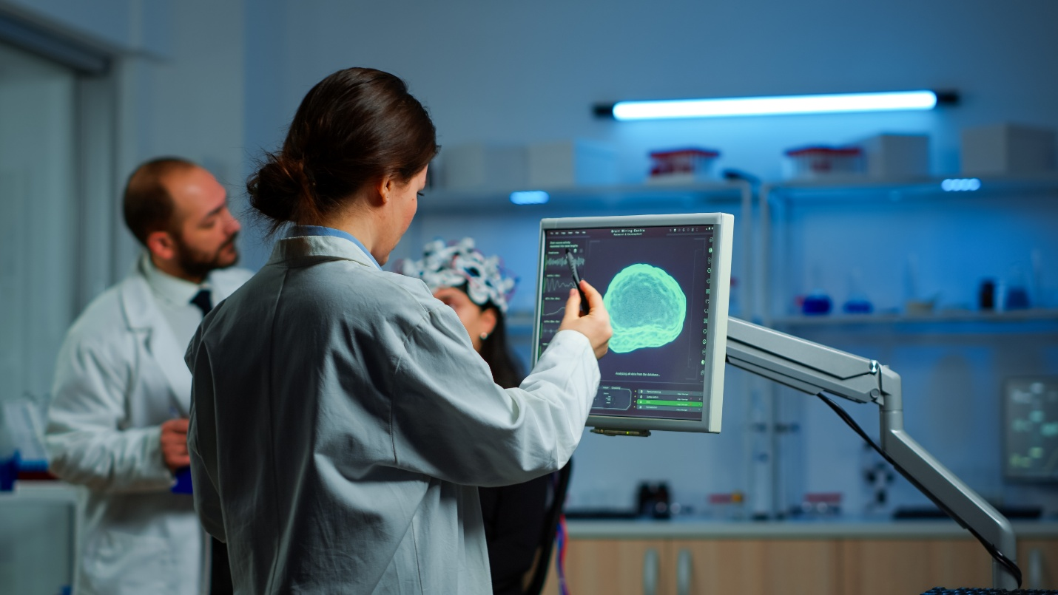
Introduction to Brain Tumors - H2
What is a brain tumor?
Brain tumors may arise from brain tissue itself (primary tumors) or spread from cancer elsewhere in the body (secondary or metastatic tumors). They can be:
- Benign (non-cancerous, slow-growing)
- Malignant (cancerous and potentially life-threatening)
- Understanding the type and location of a tumor is essential for determining the best treatment.
What Is Brain Tumor Excision? - H2
Brain tumor excision is a surgical procedure to remove abnormal brain tissue. It may involve complete or partial tumor removal depending on its type, size, and location.

When is surgical removal recommended?
Surgery is often advised when:
- The tumor is accessible and operable
- It causes symptoms due to pressure on brain structures
- A tissue sample is required for diagnosis
Goals of the surgery
- Complete removal of the tumor when possible
- Biopsy for diagnosis and treatment planning
- Relief from symptoms like headaches, seizures, or vision changes
Common Types of Brain Tumors Treated - H2
- Meningiomas
- Gliomas (astrocytomas, glioblastomas)
- Pituitary tumors
- Schwannomas
- Metastatic tumors
Symptoms That May Require Brain Tumor Surgery - H2
- Persistent headaches
- Seizures or unusual movements
- Vision or hearing loss
- Nausea/vomiting
- Cognitive and behavioral changes
Diagnostic Process Before Surgery - H2
- Neurological examination
- MRI and CT scans
- PET scan / SPECT (if required)
- Biopsy
- Functional MRI for identifying vital brain areas
Brain Tumor Excision: Procedure Overview - H2
Our surgical approach combines safety, precision, and minimally invasive techniques wherever possible:
- Pre-Operative Planning using functional imaging and neuronavigation
- Use of Intraoperative MRI (if available) for real-time accuracy
- Craniotomy to access the tumor site
- Microsurgical tools or endoscopic techniques to remove the tumor
- Closure and post-surgical monitoring
- Surgery is typically performed under general anesthesia and may last 3–6 hours depending on complexity
Risks and Complications - H2

While brain surgery is generally safe in experienced hands, some risks include:
- Bleeding or hematoma
- Infection
- Brain swelling (edema)
- Temporary or permanent neurological deficits
- Seizures
Close monitoring in our advanced neuro-ICU ensures early management of any complications.

Recovery After Brain Tumor Surgery - H2
- Hospital Stay: Usually 3 to 7 days
- Immediate Post-Operative Care: Includes neuro-monitoring and pain control
- Physiotherapy & Cognitive Rehabilitation begins early
- Return to Normal Life: Varies from 4 weeks to several months
Success Rate and Prognosis - H2
- Recovery and long-term outcomes depend on:
- Tumor type, size, and location
- Patient’s age and general health
- Surgical technology and expertise used
Why Choose Aditya Birla Hospital for Brain Tumor Surgery? - H2
- A multidisciplinary team of experienced neuro physicians and surgeons
- Advance Neuro OT & Dedicated Neuro ICU
- Multidisciplinary tumor board and neuro-oncology support
- Comprehensive post-op care and recovery planning
- NABH and ACHS accredited quality Standards
Aditya Birla Hospital is widely recognized as one of the best neurology Hospital in Pimpri, Pune, offering advanced brain tumor excision surgery through a team of highly experienced neurologists, state-of-the-art technology, and a strong focus on delivering the best possible outcomes with precision and care.
Cost of Brain Tumor Surgery in Pune - H2
Factors affecting cost:
- Type of tumor
- Complexity of surgery
- Post-surgical rehab
Insurance and cashless options available
FAQs About Brain Tumor Surgery - H2
- Is brain tumor excision safe?
A: Yes, especially when performed using modern tools by experienced surgeons.
- What happens after removal of a brain tumor?
A: Post-surgery, patients are monitored closely. Further treatment (radiation/chemo) may be needed for malignant tumors.
- Will I need radiation or chemotherapy afterward?
A: Depends on the tumor type. Benign tumors may not need additional therapy.
- How long is recovery?
A: Initial recovery is 3–4 weeks, but full recovery may take a few months.
- Will my cognitive function return?
A: In many cases, yes—especially with rehabilitation. Some functions may take time to improve.
- Can you live a normal life after a craniotomy?
A: Yes, many patients return to work and normal life after recovery.
- What is the success rate of brain tumor surgery?
A: It varies but is significantly higher with detection, benign tumors, and advanced surgical methods.

